

**SESSION 2024-25**





DEPARTMENT OF COMPUTER SCIENCE

**MINI PROJECT**

**SUBMITTED BY SUBMITTED TO**

Mohd Ismaeel Prof. Aasim Zafar

23CAMSA159 Prof. Swaleha Zubair

GM2685 Ms. Priti Bala

Dr. Asif Irshad Khan

Contents

BookHUB AMU 4

1. Introduction 4
2. Problem Statement 4
3. Study of the Existing System 4
4. Proposed Solution 5
5. Scope of the Project 5
6. Preliminary System Design 6
   * **Frontend**: React.js-based user interface. 6
   * **Backend**: Node.js and Express.js for server-side logic. 6
   * **Database**: MongoDB for storing book data, user profiles, and access logs. 6

* **6.3 Data Flow**: Data flows between the frontend and backend through RESTful APIs, with data being fetched, updated, and managed through secure database operations. 6

1. Feasibility Analysis 6

* 7.1 Technical Feasibility: Given the widely-used MERN stack and the availability of skilled

developers, the project is technically feasible and can be implemented using existing technology 6

* **7.2 Economic Feasibility**: The project is cost-effective as it uses open-source technologies, and the free access model eliminates the need for payment processing features 6
* **7.3 Operational Feasibility**: The application is expected to operate efficiently in the university environment, providing seamless access to academic resources without significant operational

challenges 7

1. Tools and Technologies 7
   * React.js : For frontend 7
   * Node.js and Express.js: For backend 7
   * Visual Studio Code: Integrated Development Environment (IDE). 7
   * **Git**: Version control 7
   * Postman: For API testing. 7
   * **MongoDB**: NoSQL database for storing and managing data. 7
2. Expected Outcomes 7
   * A fully functional digital bookstore application. 7
   * Documentation including user manuals and system architecture diagrams. 7
   * The successful launch of the application within AMU. 7
   * Positive feedback from students and faculty regarding accessibility and usability. 7
3. Risks and Challenges 7
   * **Data Security**: Ensuring user data and book resources are protected. 7
   * **Scalability**: Handling high volumes of users and data. 7

* + Implementing robust encryption and authentication mechanisms. 7
  + Planning for scalable infrastructure from the beginning 7

1. References 7

* Research papers on digital libraries and open educational resources. 7
* Documentation and tutorials on the MERN stack. 8

# BookHUB AMU

## Introduction

* + **1.1 Background**: The digital transformation of educational resources has become crucial in modern academia. Aligarh Muslim University (AMU), known for its rich academic

heritage, requires a dedicated platform where students, faculty, and staff can access academic books efficiently. The AMU Free Bookstore Application aims to provide this by leveraging modern web technologies, ensuring that academic resources are readily

available to all members of the university at no cost.

* + **1.2 Objective**: The primary objective of this project is to develop a user-friendly, accessible, and free digital bookstore for Aligarh Muslim University. The platform will

allow users to browse, search, and download academic books, fostering a more inclusive and resourceful learning environment.

## Problem Statement

* + **2.1 Problem Description**: **:** Libraries and seminar libraries at AMU face challenges such as limited physical space, availability constraints, and access issues, particularly during off-hours or emergencies (e.g., pandemics). There is a need for a centralized, digital

solution that addresses these limitations by providing free, on-demand access to a vast array of academic books.

* + **2.2 Importance of the Problem**: By solving this problem, the application will remove

barriers to accessing educational resources, thereby enhancing the academic experience at AMU. This project is significant in ensuring that financial constraints do not hinder access to essential academic materials.

## Study of the Existing System

* + **3.1 Overview of the Existing System :** Currently, AMU relies on physical libraries and seminar libraries, supplemented by some online resources. These systems, however, are fragmented and lack a unified platform for free, comprehensive access to academic books.
  + **3.2 Limitations of the Existing System :** The existing system is limited by physical availability, costs associated with purchasing books, and a lack of a centralized digital repository, leading to accessibility issues for students and faculty.
  + **3.3 Comparative Analysis :** While some universities have adopted digital libraries, they often include subscription-based models, which are not entirely free. The proposed

solution distinguishes itself by offering all resources at no cost.

## Proposed Solution

* + **4.1 Overview**: The proposed solution is a web-based application that provides free access to academic books for the AMU community. Developed using the MERN stack, the

application will be scalable, user-friendly, and accessible from any device with internet connectivity.

### 4.2 Key Features:

* + - **Free Access to Books**: All books on the platform are available for free.
    - **User-Friendly Interface**: Simplified navigation and search functionalities.
    - **Secure Login System**: Secure access for students, faculty, and staff.
    - **Responsive Design**: Accessible on desktops, tablets, and smartphones.
    - **Admin Dashboard**: For efficient management of book inventory and user activities.
  + **4.3 Innovation**: The platform’s core innovation lies in its cost-free access model,

supported by modern web technologies that ensure efficiency, security, and scalability.

## Scope of the Project

### 5.1 Inclusions:

* + - Development of a digital bookstore platform with a user-friendly interface.
    - Integration of a secure login system for authenticated access.
    - Administrative tools for managing book inventory and user data.
    - Responsive design for cross-platform accessibility.

### 5.2 Exclusions:

* + - The project does not include the development of a payment gateway since all resources are free.
    - Physical book management or integration with external paid services.

## Preliminary System Design

* + **6.1 High-Level Architecture**: The application will follow a client-server architecture.

The frontend will be built using React.js, communicating with a backend server powered by Node.js and Express.js, with data stored in MongoDB.

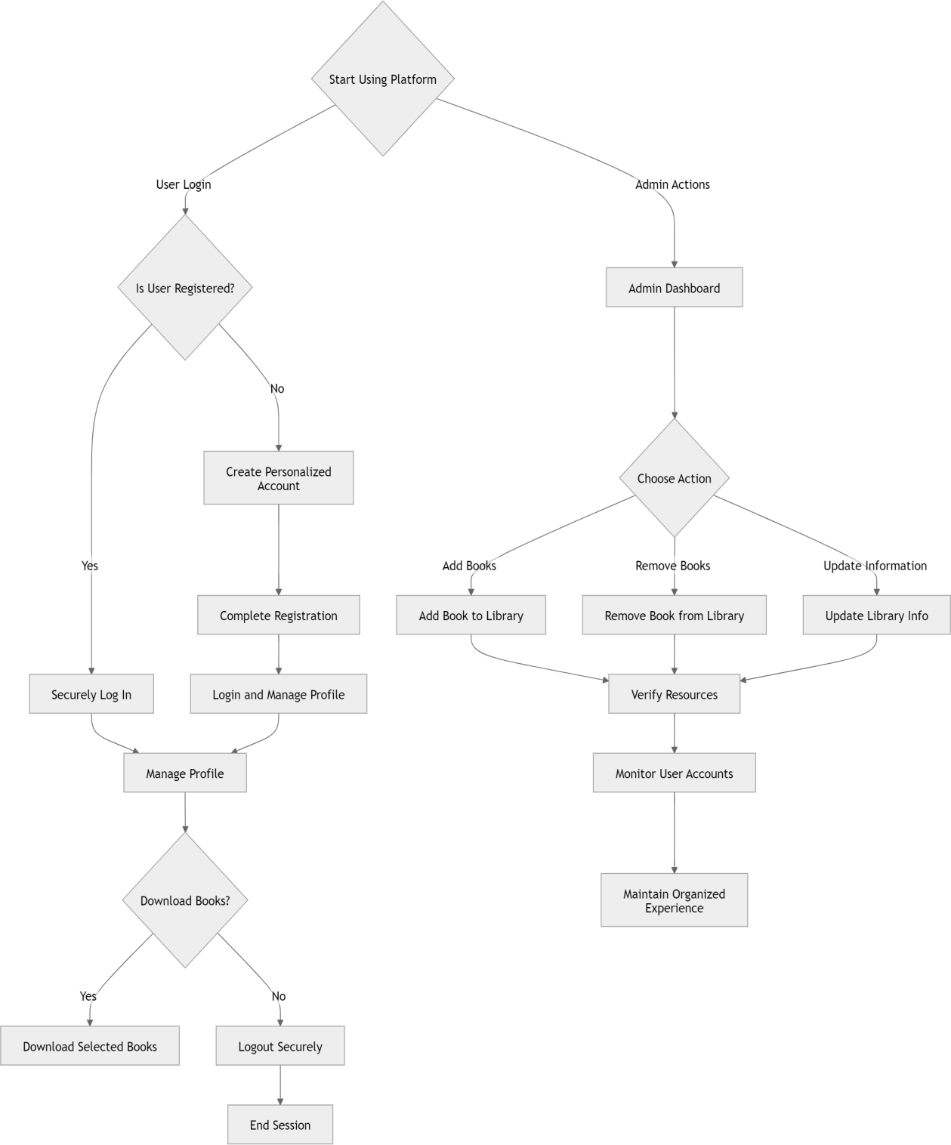

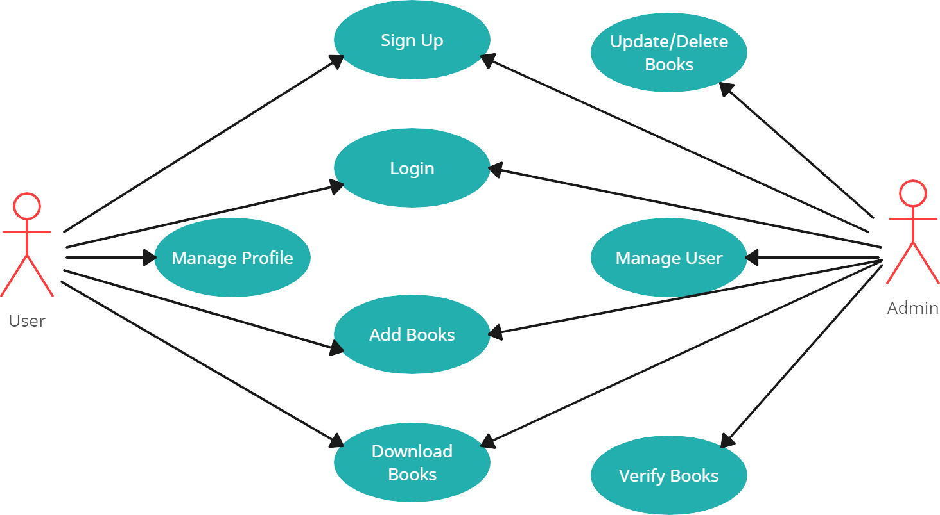

### 6.2 Major Components:

* + - **Frontend**: React.js-based user interface.
    - **Backend**: Node.js and Express.js for server-side logic.
    - **Database**: MongoDB for storing book data, user profiles, and access logs.
  + **6.3 Data Flow**: Data flows between the frontend and backend through RESTful APIs, with data being fetched, updated, and managed through secure database operations.

## Feasibility Analysis

* + **7.1 Technical Feasibility**: Given the widely-used MERN stack and the availability of skilled developers, the project is technically feasible and can be implemented using existing technology.
  + **7.2 Economic Feasibility**: The project is cost-effective as it uses open-source

technologies, and the free access model eliminates the need for payment processing features.

* + **7.3 Operational Feasibility**: The application is expected to operate efficiently in the university environment, providing seamless access to academic resources without

significant operational challenges.

## Tools and Technologies

### 8.1 Programming Languages:

* + - **React.js :** For frontend
    - **Node.js and Express.js:** For backend

### 8.2 Development Tools:

* + - **Visual Studio Code**: Integrated Development Environment (IDE).
    - **Git**: Version control.
    - **Postman**: For API testing.

### 8.3 Database:

* + - **MongoDB**: NoSQL database for storing and managing data.

## Expected Outcomes

### 10.1 Deliverables :

* + - A fully functional digital bookstore application.
    - Documentation including user manuals and system architecture diagrams.

### 10.2 Success Criteria:

* + - The successful launch of the application within AMU.
    - Positive feedback from students and faculty regarding accessibility and usability.

## Risks and Challenges

### 11.1 Potential Risks:

* + - **Data Security**: Ensuring user data and book resources are protected.
    - **Scalability**: Handling high volumes of users and data.

### 11.2 Mitigation Strategies:

* + - Implementing robust encryption and authentication mechanisms.
    - Planning for scalable infrastructure from the beginning.

## References

* + Research papers on digital libraries and open educational resources.
  + Documentation and tutorials on the MERN stack.